ASSIGNMENT 5

M’nadi Grant

180919

* **Run and understand the web interface, including the web forms programming in flask**

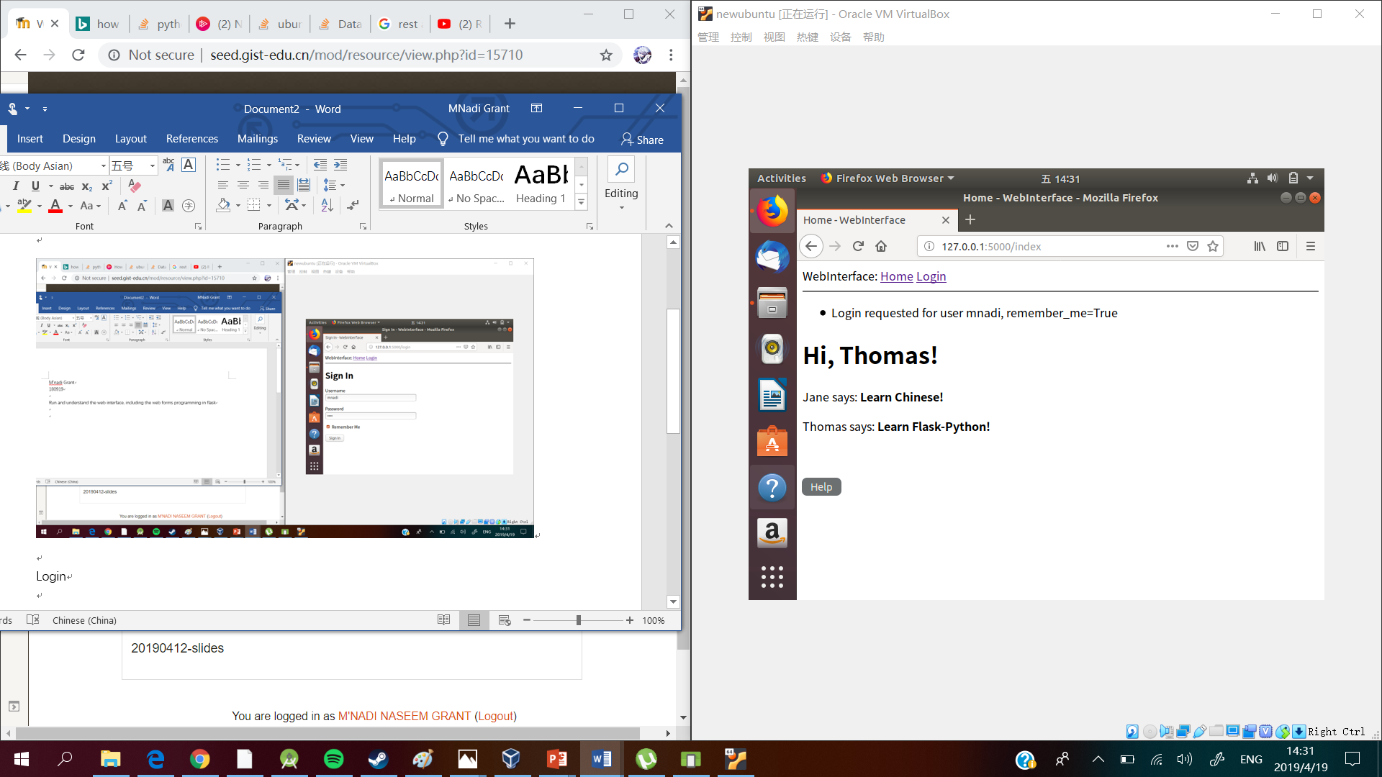

The render_template() function is used to convert the application templates into HTML Pages. This function takes a template filename and a variable list of template arguments and returns the same template, but with all the placeholders in it replaced with actual values.

Web forms in this application uses the Flask_WTF extension. This extension uses Python classes to represent web forms. A form class simply defines the fields of the form as class variables.

* **Refractor your previous web service with web forms, e.g. “Tasks” and “User Admin”**

Login Web form

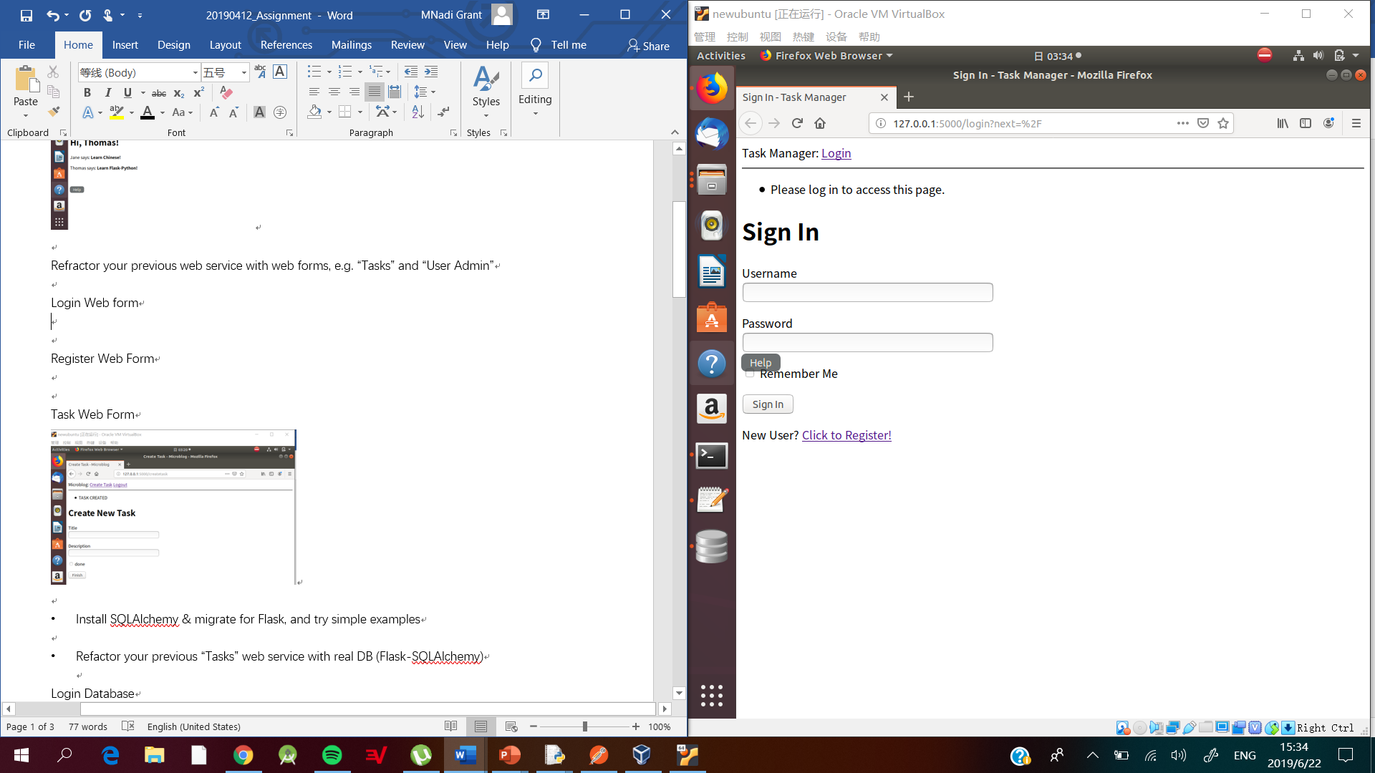

Register Web Form

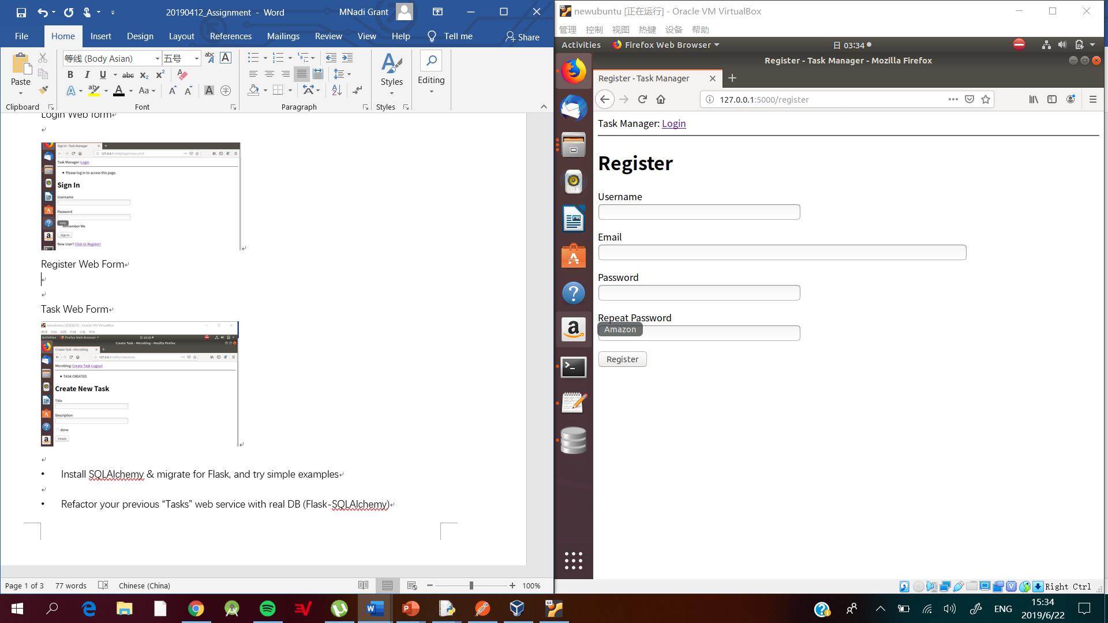

Task Web Form

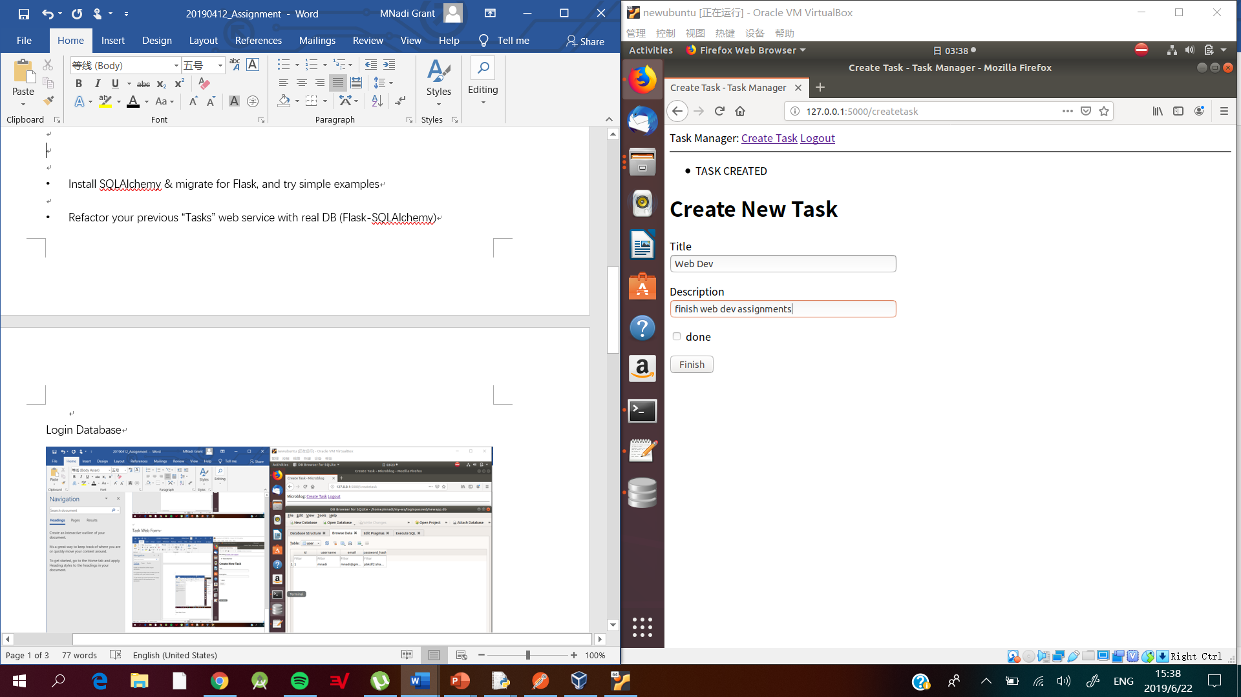

* Install SQLAlchemy & migrate for Flask, and try simple examples

Installing SQLAlchemy

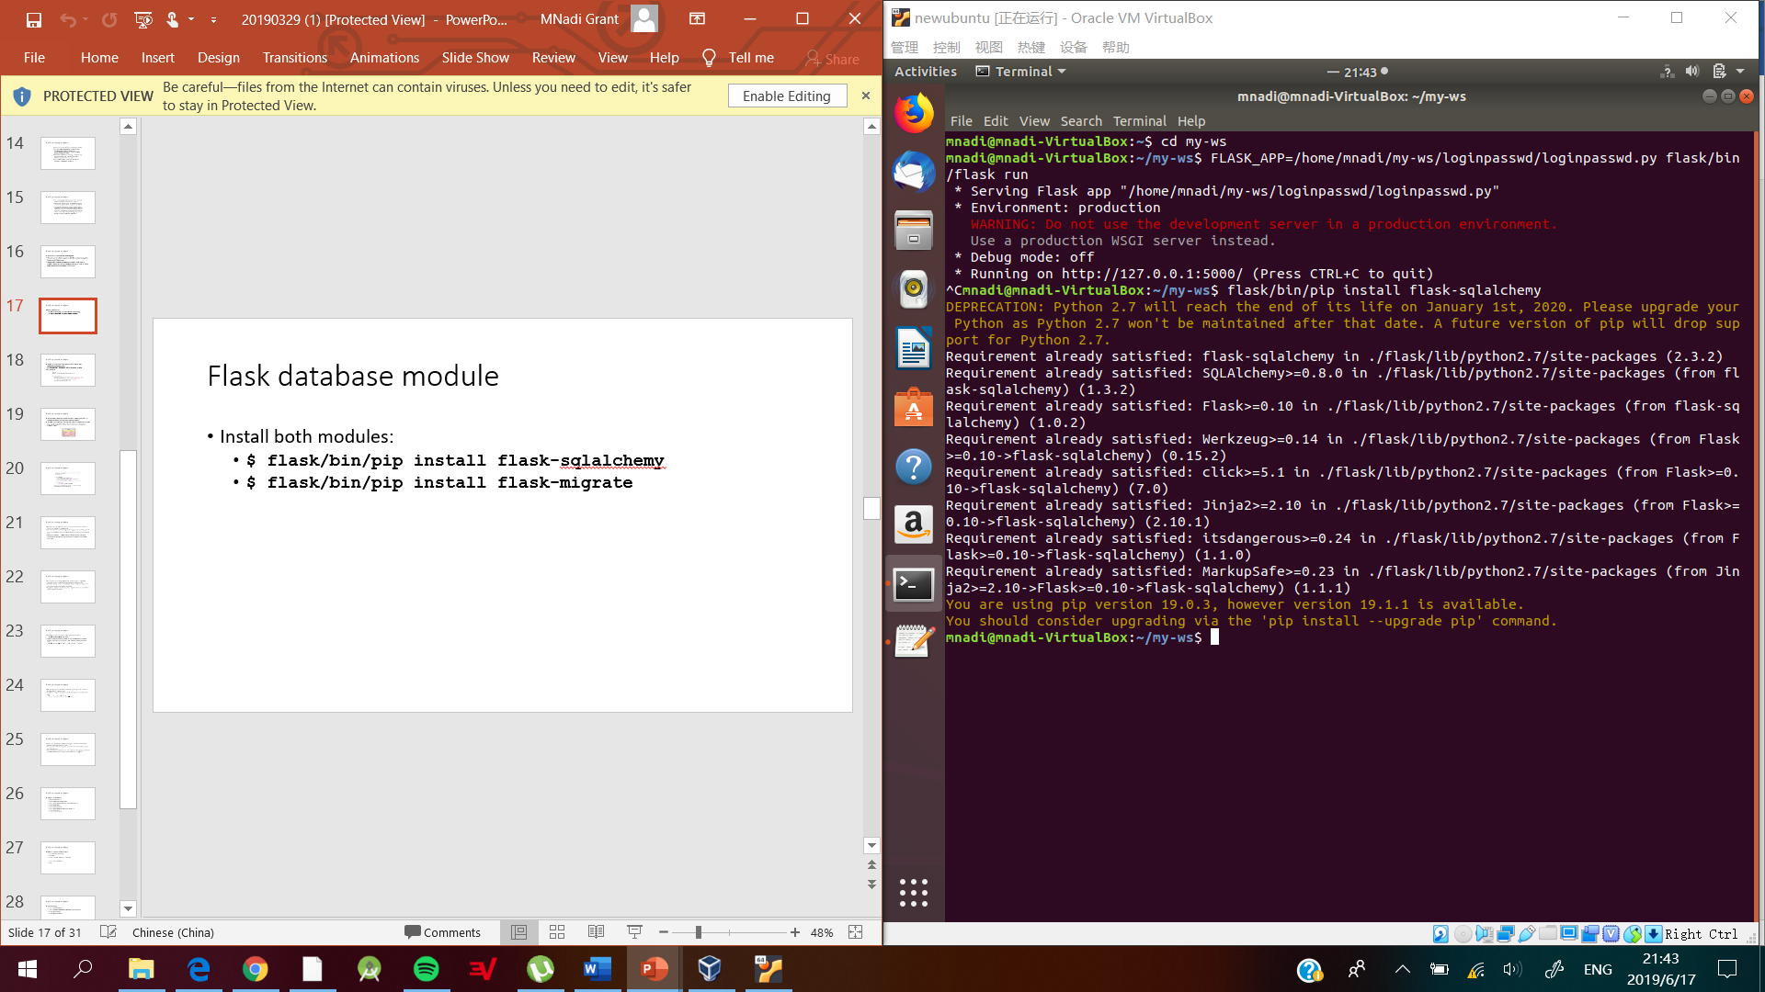

* Installing Flask-migrate

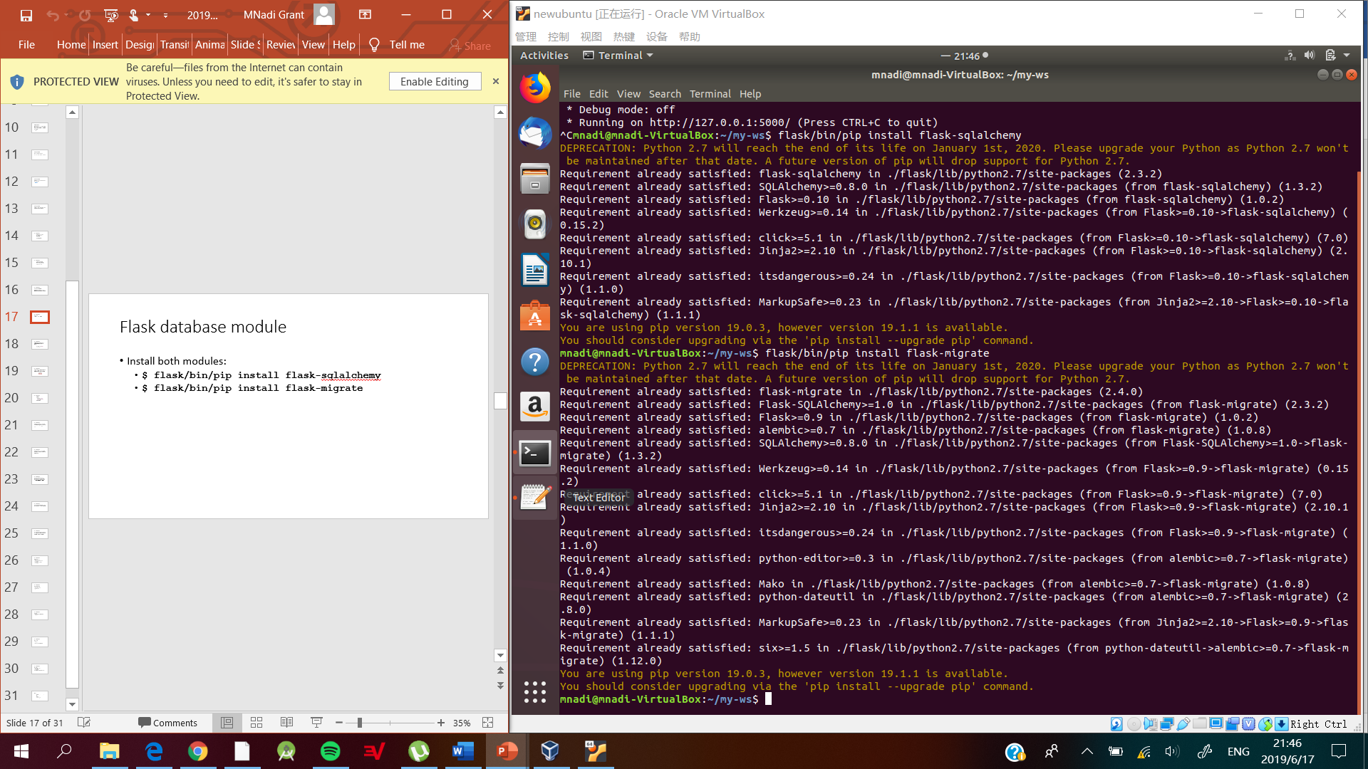

* Migrating database

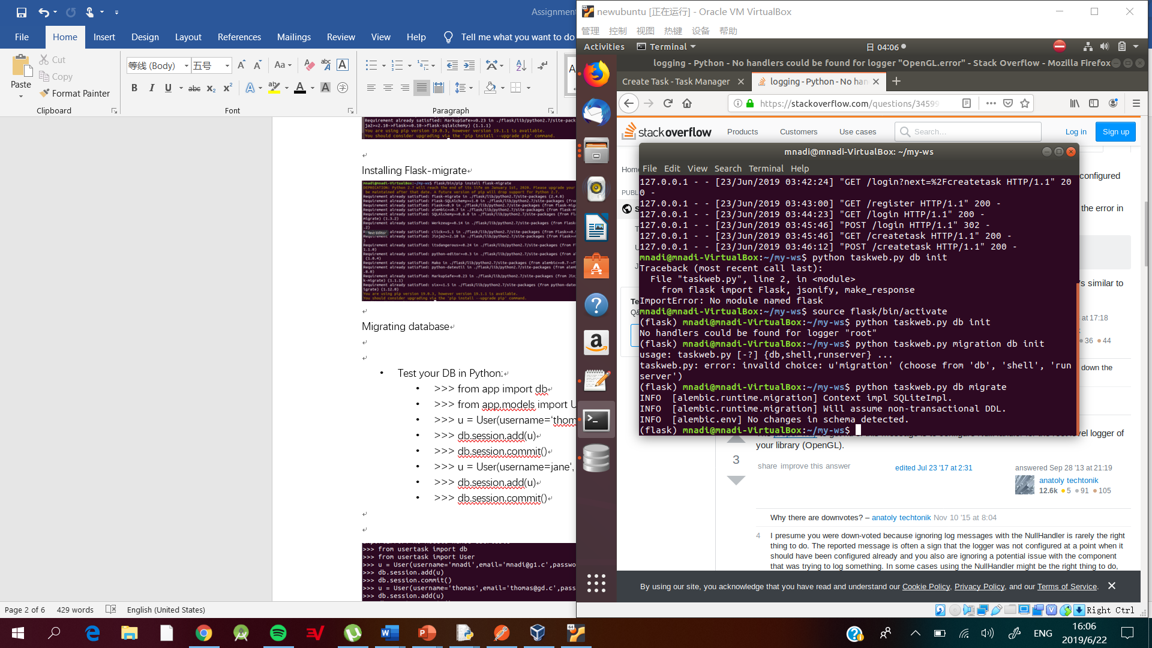

* Updating database

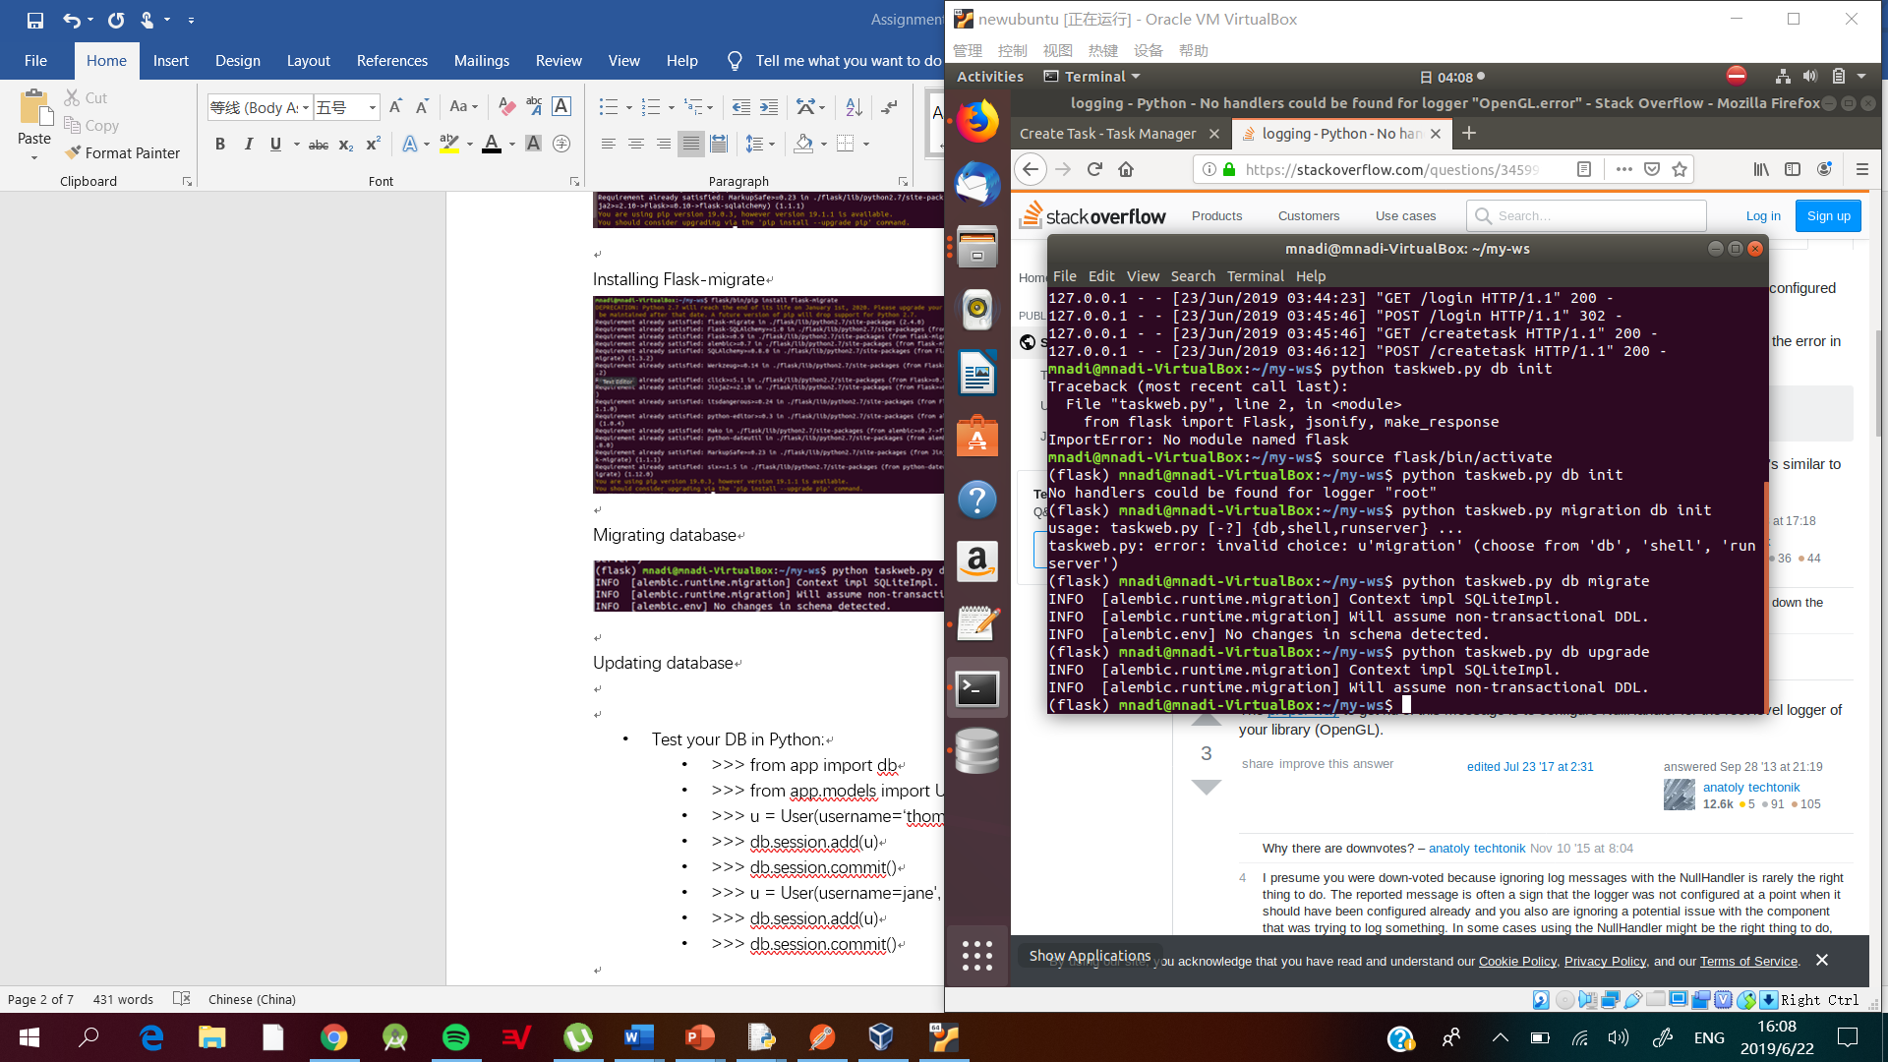

**NOTE: Due to no changes being made to the database the following was executed.**

* Refactor your previous “Tasks” web service with real DB (Flask-SQLAlchemy)

Task Database

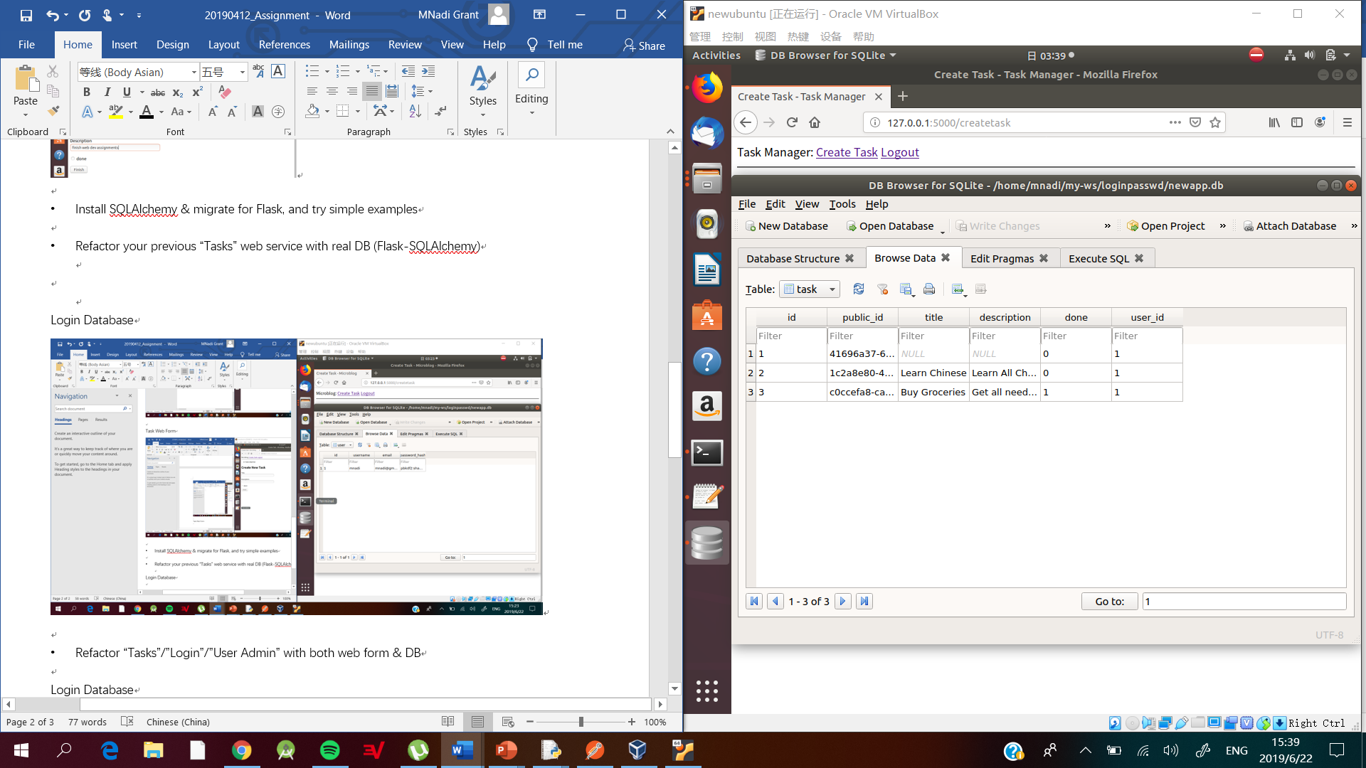

User Database

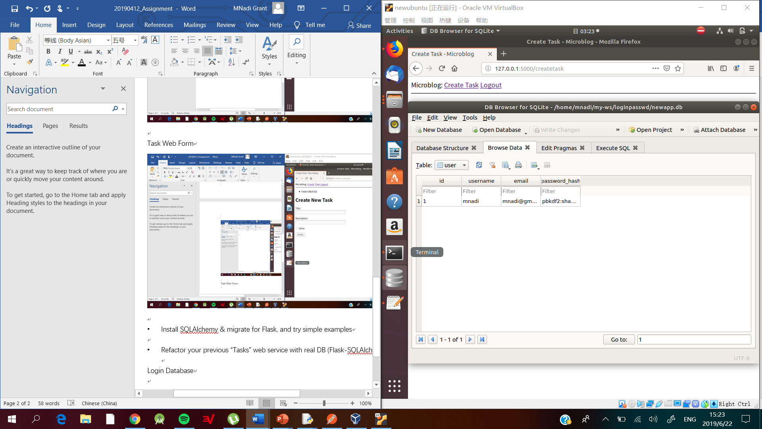

* Refactor “Tasks”/”Login”/”User Admin” with both web form & DB

User Admin Web Form and Database

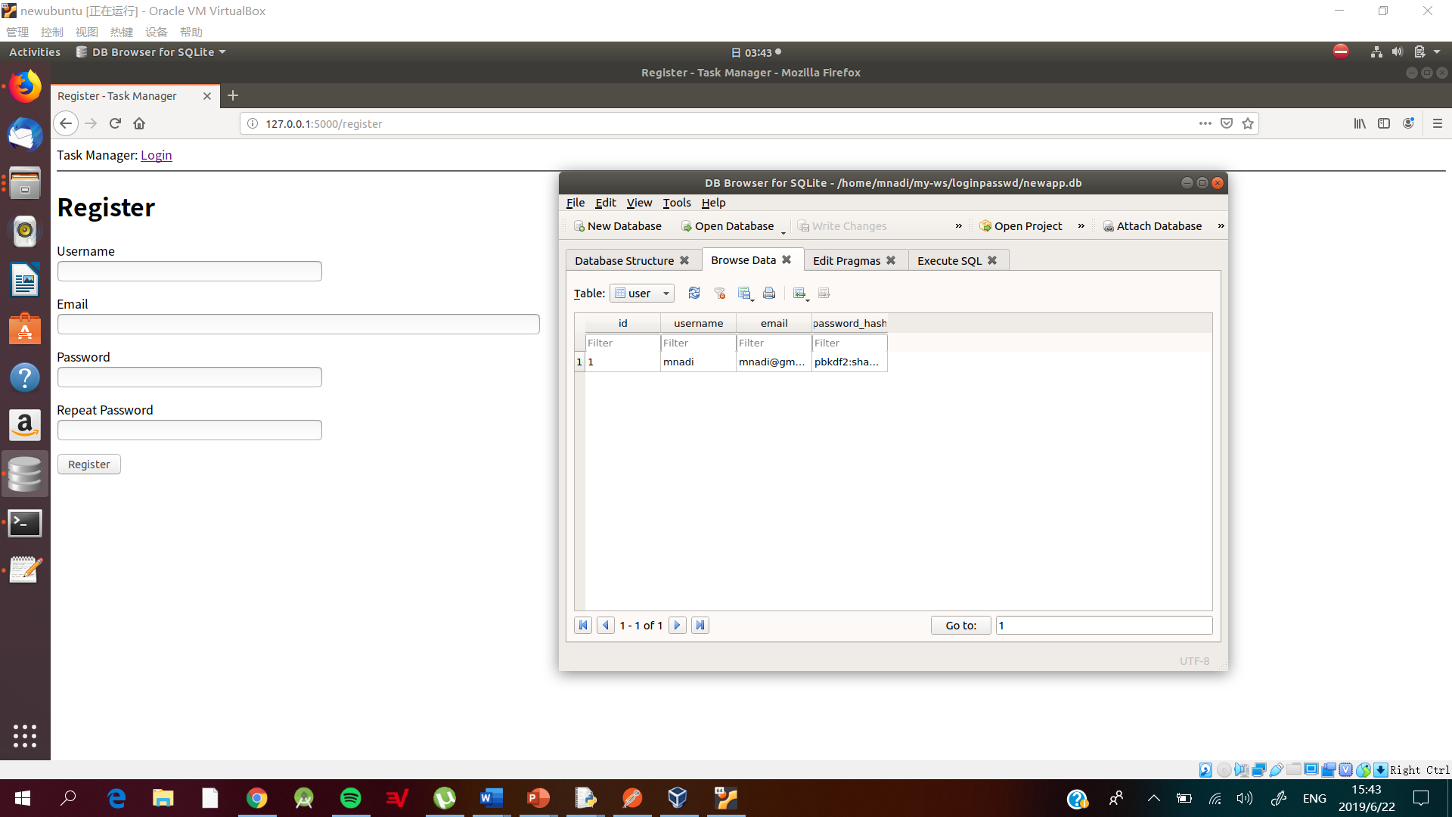

Login Web Form

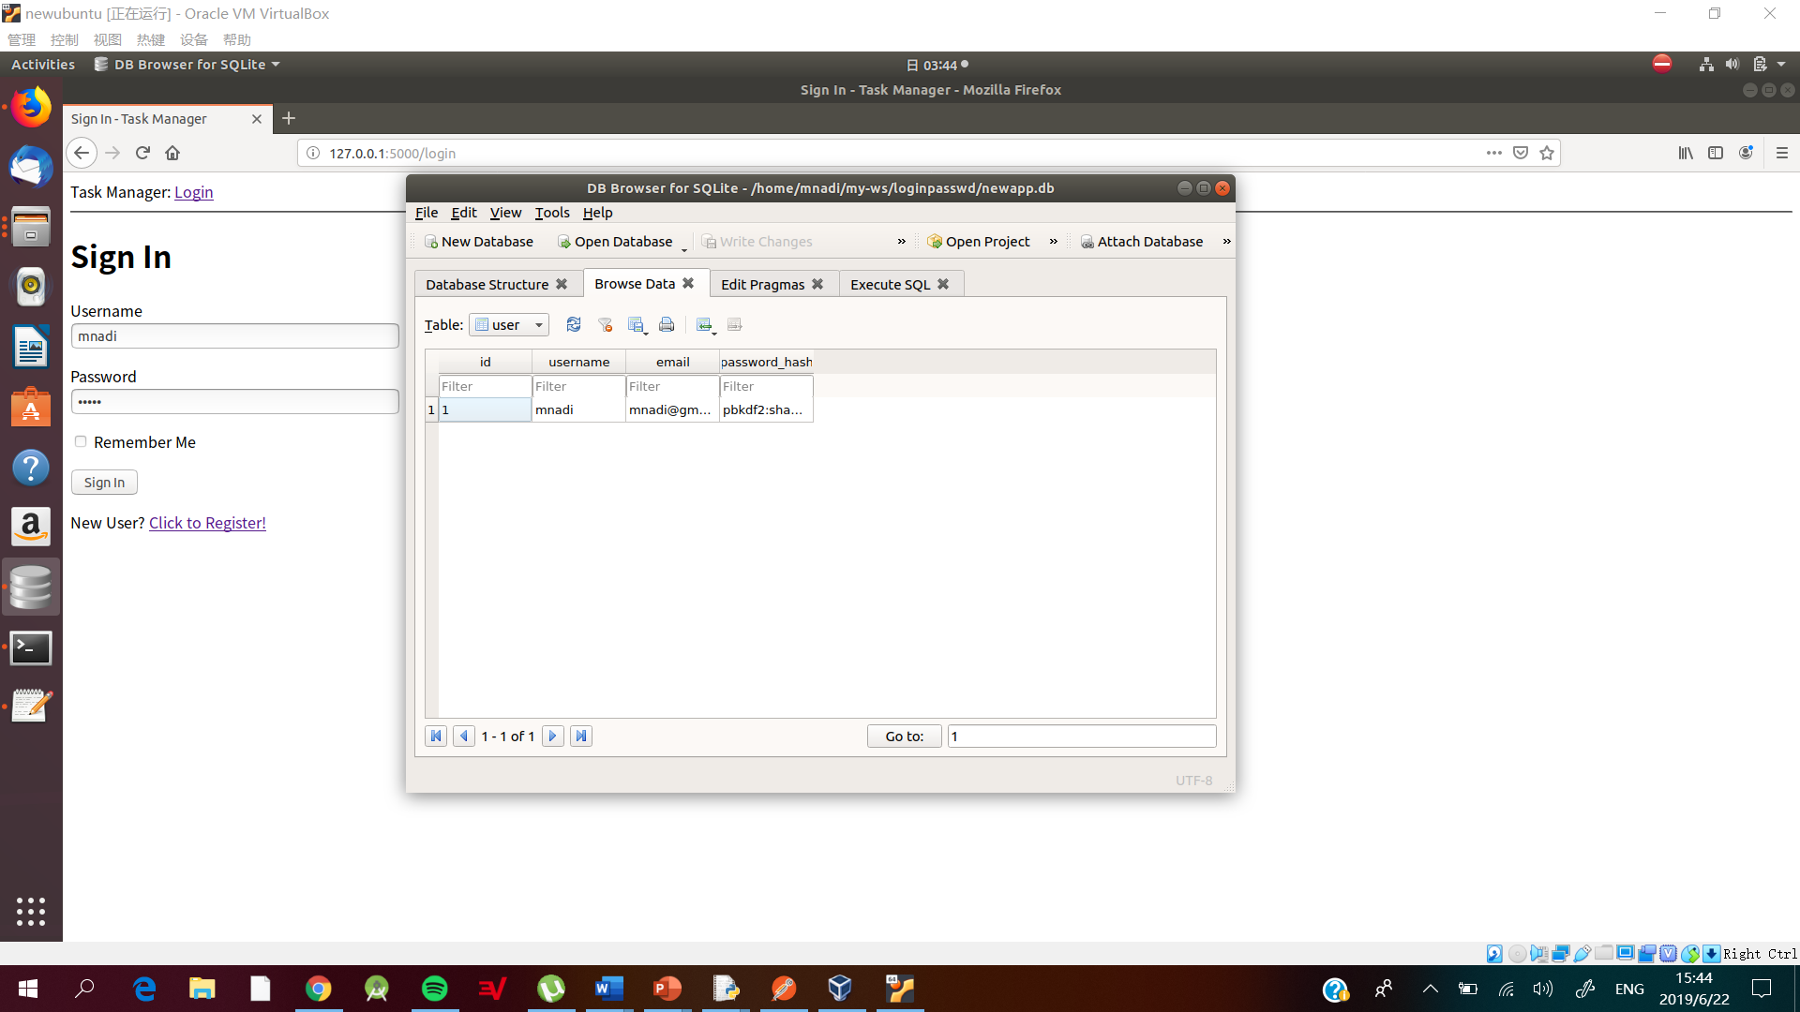

Task Web Form with functional Database

